Two Nations Live on the Edge pages 622-627

Warm up: Why do you think fear is such a good motivator to get people do things they wouldn’t normally do?

Part I: Brinkmanship Rules U.S. Policy 622-623

- What caused the arms race between the Soviet Union and the United States?

- Explain Brinkmanship

Summary part I: Explain 1 similarity and 1 difference between the nuclear threat of the 1950s and the terrorist threat today.
Similarity | Difference

Part II: The Cold War Spreads Around the World pages 623-626

- What was the role of the CIA in the Cold War?

- Summarize the Warsaw Pact.

- What was the cause and effect of the Eisenhower Doctrine?
Cause | Effect

- Why was the U.N. no help in the Hungarian Revolution?

Summary part II: Why do you think the U.S. did not help Hungary?

Part III: The Cold War Takes to the Skies pages 626-627

- Summarize the Space Race.

- Summarize the U-2 incident.

- How were the Space Race and the U-2 incident similar and different
Similar | Different

Summary III: Which of the two superpowers do you think contributed more to the Cold War during the 1950s? Explain your answer using facts from this assignment.

Part IV: Picture Analysis

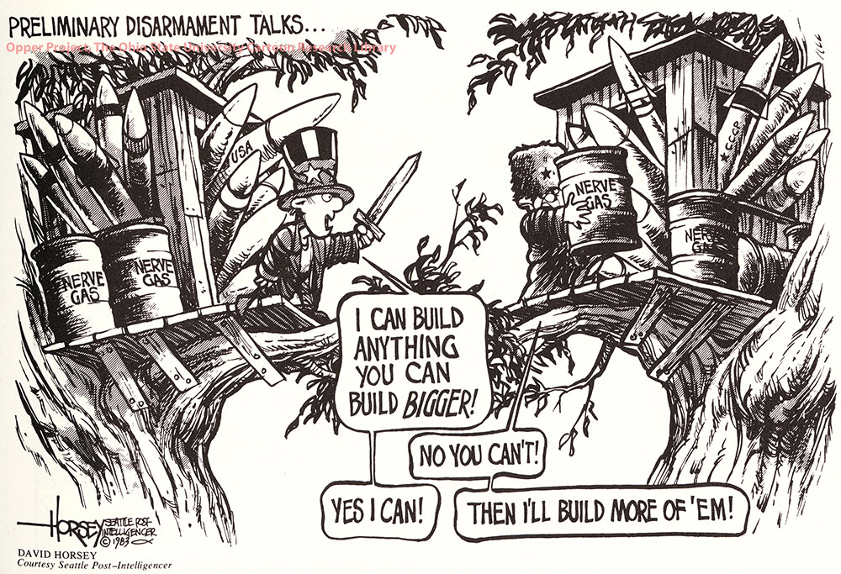
People

Objects

Setting

Engagement

Summary

