The Cold War at Home
Warm Up: Read A Personal Voice on page 616. How is this similar to Muslims today?

Part I: Fear of Communist Influence pages 616-618
- What caused Americans to be afraid of Communism?

- How did the Loyalty Review Board pose a threat to civil liberties?

- What was the purpose of the House Un-American Activities Committee (HUAC)?

- Why was Hollywood a target of anti-communist investigations by Congress?

Summary part I- Today we have Homeland Security. There are five homeland security missions: Prevent terrorism and enhancing security; Secure and manage our borders; Enforce and administer our immigration laws; Safeguard and secure cyberspace; Ensure resilience to disasters
What is one similarity and one difference between the Anti-Communist laws and Homeland Security?
Similarity | Difference

Part II – Spy Cases stun the Nation pages 618-620
- Summarize the Alger Hiss case.

- Summarize the Rosenbergs case.

- Why did the Hiss and Rosenbergs cases heighten the anti-Communist mood in America?

Summary Part II – What is one similarity and one difference between the Hiss case and the Rosenberg case?
Similarity | Difference

Part III – McCarthy Launches His Witch Hunt pages 620-621
- What was McCarthyism?

- Summarize how McCarthy lost his power.

- What other measures were taken to root out Communism?

Summary Part III – These witch hunts were ultimately found unconstitutional. Why do you think people were willing to accept these unconstitutional acts?

Part IV – POSES
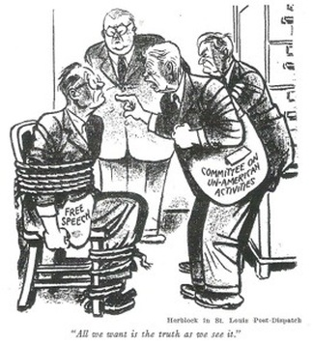
People:

Objects:

Setting:

Engagement:

Summary:

