The Business of America

Part I: American Industries Flourish pages 422-424

- What are two ways Calvin Coolidge encouraged the growth of business?

- What are 3 ways the automobile industry impacted the daily life of the average American?

- How did the automobile change where people lived?

- Explain 3 reason the airplane industry increased.

- Summary part I: How did the widespread use of the automobile and airplane affect the lives of Americans?

Part II: America’s Standard of Living Soars pages 425-426

- How did the use of electricity affect Americans’ lifestyle?

- How was advertising changed with the flood of new goods?

- Summary part II: In your opinion, which was more important to the lives of the average American, the automobile or electricity? Explain your answer

Part III: A Superficial Prosperity pages 426-427

- What were two negative affects of producing so many goods?

- What was the purpose of the installment plan?

Advantage of buying on credit | Disadvantage of buying on credit

- Summary part III: How do you think the changes in spending will affect the economy?

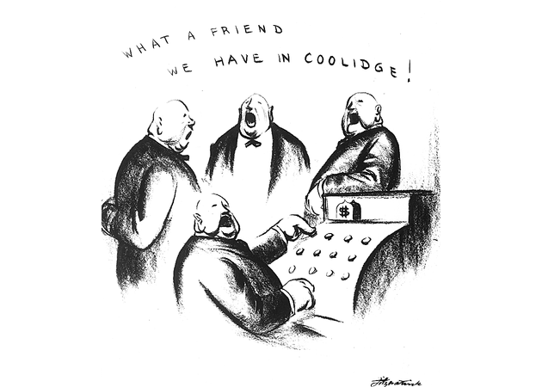
Part IV: Visual Analysis- analyze the picture and answer the question below.

- The cartoon criticizes President Coolidge by suggesting what?

