Taking on Segregation pages 700-704
Warm up: Write down the definition of de facto segregation and de jure segregation. (Pg. 718)

Part I: The Segregation System pages 700-702

- What were the effects of the Supreme Court decision Plessy v. Fergusan?

- What is one similarity and one difference between segregation on the North vs. in the South
  - Similarity-

  - Difference-

- How did World War II lay the groundwork for the fight against segregation?

Summary part I: Predict 2 positive and 2 negative outcomes of African Americans fighting against segregation.
Positive | Negative

Part II: Challenging Segregation in Court pages 702-703

- How did the NAACP and Charles Hamilton Houston use legal strategy to fight segregation?

- How did Brown v. Board of Education affect schools outside of Topeka, Kansas?

Summary part II: Predict 2 positive and 2 negative outcomes of the Brown v. Board of Education decision
Positive | Negative
Part III: Reaction to Brown v. Board of Education pages 703-704

- Why do you think reactions to The Brown ruling were mixed?

- What caused the second ruling, known as Brown II to be handed down?

- Summarize the events of The Little Rock Nine
First
Then
Finally

Summary part III: What effect do you think television coverage of the Little Rock Nine incident had on the nation?

Final Summary
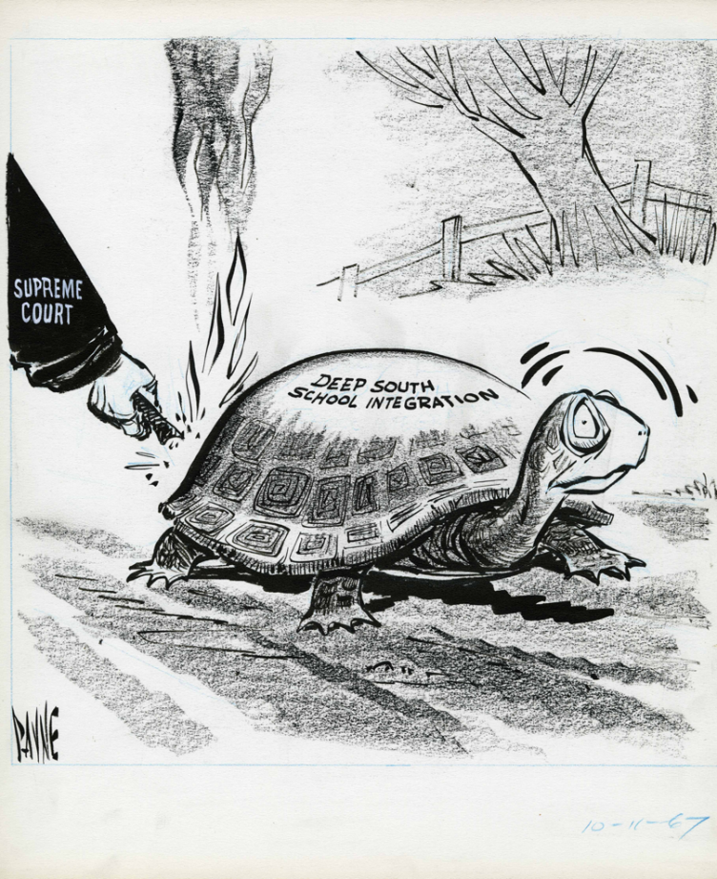
P:

O:

S:

E:

S:

