Reading Passage #1: The Cuban Revolution of 1868

By the end of the 19th century, Spain had lost all of its New World colonies except Cuba and Puerto Rico. However, many Cubans no longer wanted to live under Spanish rule. In 1868, Cuban revolutionaries declared their independence from Spain and began a ten-year war. Due to problems in Europe, Spain was unable to devote its full attention to this rebellion until 1876. By 1878, the rebellion was stamped out. Because of this revolution, over 100,000 Cubans fled their homes and moved to the United States, where most settled in New York, Key West, and Tampa.
The 1868 Revolution did not go unnoticed in the United States. Many Americans were sympathetic toward the Cuban rebels, and some even saw similarities between the Cuban war for independence and our own Revolutionary War against Great Britain more than a century before. Some Americans supplied the Cuban rebels with guns, money, and other supplies. The Spanish government protested to U.S. officials, but received no response. In one incident in 1873, American Captain Joseph Fry, a Tampa native, almost brought the United States and Spain to war. Fry, a former Confederate naval officer in the American Civil War, was captain of the S.S. Virginus. Carrying guns and 300 Cuban rebels, Captain Fry sailed to Cuba to aid in the Cuban fight against Spanish forces on the island. However, the Spaniards captured the Virginus before it reached its destination. After a speedy trial, Captain Fry and fifty-three others (mostly Americans) were executed by a firing squad. A British warship captain intervened on behalf of the remaining rebels and crew, but for a few weeks it seemed likely that the United States and Spain would go to war over this incident. Finally, the U.S. Attorney General decided that the S.S. Virginus did not travel to Cuba on an official United States visit. War was averted for the time being. But hard feelings continued to exist.

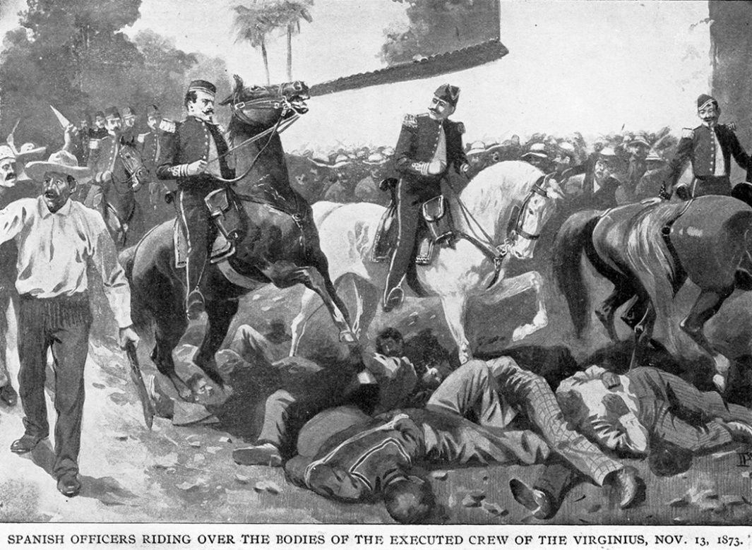
Before a British warship commander could intervene, Spanish soldiers trample the bodies of American crewmen of the S.S. Virginius. The British commander did manage to save the lives of the remaining members of Fry’s crew. When news of this episode reached America, how do you think Americans responded? Would the U.S. have been justified in declaring war to avenge the death of fifty-four Americans who were caught smuggling weapons into Cuba to aid Cuban rebels, even though the Spanish government had asked the U.S. to stop the flow of aid to rebels from the U.S.?

Reading Passage #2- Vicente Martinez Ybor and His “City”

Born in Spain in 1818, Vicente Martinez Ybor moved to Havana, Cuba, when he was fourteen in order to escape mandatory military duty in Africa. He became a successful tobacco broker by the age of seventeen, married, and had four children. After the early death of his young wife, he remarried. His second wife gave him eight more children, of which six survived infancy. His second wife’s family gave him $100,000.
With this money, Ybor opened his own cigar factory in 1853. But Spanish taxes and regulations on Cuban industry soon pushed Ybor into opposing the Spanish government in Cuba. He openly supported rebels when the Cuban Revolution of 1868 started, and narrowly escaped arrest by dodging authorities before boarding a boat for Key West in 1869.
Ybor quickly reestablished his cigar business, hiring skilled Cuban refugees who had also fled the violence of the revolution. By 1875, Ybor’s cigar rollers were producing more than ten million cigars a year. But there were problems with his factory’s Key West location. Cigar workers in that community had formed a labor union, and were threatening to strike. Also, the only way to ship his product off of the island was by boat, which was time-consuming and powerless against the difficulties caused by unpredictable weather.
Upon receiving word of Henry Plant’s railroad line in Tampa in 1884, Ybor realized that a railroad would provide better shipment of his cigars across the nation. He made a decision. He bought forty acres just outside of Tampa and soon made that property his new base of operations. Other cigar industry leaders followed Ybor to Tampa, but Ybor built the world’s largest cigar factory. Eventually, thousands of skilled cigar makers came to Tampa and worked in Ybor’s factory. Ybor ordered the construction of worker’s cottages and rented them to his workers for $1.50-$2.50 a week. Unlike other factory owners, Ybor also allowed his workers the opportunity to purchase these homes for $400-$900. Ybor knew that if his workers owned their homes, they would be more likely to stay in Tampa. His factory and the surrounding homes that were built came to be known as “Ybor City.” 1) Why did Ybor support the Cuban Revolution of 1868? 2) Why did Ybor move his cigar business from Key West to Tampa? 3) Why would Tampa’s access to Henry Plant’s railroad have been a crucial factor in Ybor’s decision to relocate his business to Tampa?

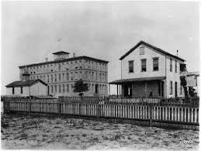
In this picture, the large building to the left is Ybor’s cigar factory, while the building on the right is a worker’s cottage. Hundreds of these cottages were built around Ybor’s factories after this picture was taken. What would be some advantages for a factory owner to build his workers’ homes within a short distance of the factory, and then allowing them to purchase the homes instead of renting them?

Reading Passage #3-Jose Marti

Often called the “George Washington of Cuba,” Jose Marti was born in Havana, Cuba, on January 28, 1853. Influenced by a childhood teacher, Marti was very active in the Cuban Revolution of 1868. In 1871, he was forced to leave Cuba by the colonial government because of his revolutionary activities. He was sent to Spain, where he studied law. Allowed to return to Cuba in 1878, he once again became involved in anti-Spanish activities and was banished from the island for life.
Marti settled in New York, where he lived from 1881 until 1895. He spent a great deal of his time speaking to large groups of Cubans in New York about the Cuban people’s right to govern themselves. New York Cubans responded by pledging their support, their money, and, most importantly, themselves when the time was right for another Cuban revolution.
At the request of a few powerful Cubans in Florida, Marti agreed to travel south. He boarded a train in November of 1891 and headed to Tampa. Marti was immediately successful in gaining the support of Cubans in Tampa. Later, he would make dozens of trips to Tampa and Key West to gather men and materials for another rebellion to free their homeland.
The entire Tampa community called for action to be taken to bring about Cuban independence. With the blessings of the cigar factory owners, Marti was allowed to ask for support from the cigar rollers during working hours. Although the workers were already committed to giving a day’s wage every week, Marti asked for more. Of course, he received it. As one historian wrote, “The Cuban cigar rollers looked at the independence movement as some people would look at donating to the church. They would give ten percent of their salaries to the cause of the revolution.” No worker could resist Marti’s impassioned pleas. When he spoke, “…it was like a preacher at a revival. The Cubans wept. They carried him on their shoulders through the streets.” Some people were so caught up in the move for Cuban independence that they sold their homes and donated the money.
Later, Marti was nearly killed in Ybor City on one of his visits when Spanish secret agents bribed his bodyguards and attempted to poison him. Realizing that the time to act was near, Marti prepared the rebellion to begin in January 1895. The exact orders were rolled into a cigar and sent out from a Tampa cigar factory. They were then smuggled into Cuba and delivered to Juan Gualberto Gomez, Marti’s most trusted assistant in Cuba. The revolution began again in several locations across the island on February 24, 1895. One by one, the leaders of the rebellion snuck onto the island. However, Marti was killed in a battle at Dos Rios on May 19, 1895. Though the rebellion raged on, its primary leader and inspiration was dead.
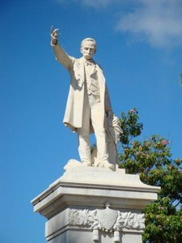
To the left is a statue of Jose Marti in Central Park, Havana, Cuba. Marti appears to be leading the Cuban people to freedom. Below is a piece of artwork that is on permanent display in a museum in Havana showing Simon Bolivar, Abraham Lincoln, and Jose Marti. Since his death, Marti has attained an almost mythical status in Cuba. Why do you think this is so? Why would the person who created the artwork below have shown Marti side by side with Lincoln?
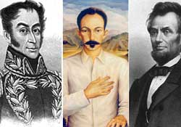

Reading Passage #4-The Cuban Revolution of 1895

The Cuban leaders had learned valuable lessons from the last rebellion in 1868-1878. They knew that their forces needed to take the war to western Cuba, where most of the Cuban people lived and worked on sugar plantations. If successful, they would conduct a “torch” war. Rebel fighters would burn all of the sugar fields and destroy property. Their goal was to force the Spanish to realize that it would be wasteful to throw men and money into a war to salvage an island where nothing remained. The Spanish forces, however, knew that the key to their success was to keep the fighting bottled up in the eastern part of the island.
By the end of 1896, the rebels had gained control of much of the island. Their “torch” warfare had worked. Almost all of the economic activity on the island had been paralyzed. But instead of retreating and allowing the Cubans their independence, Spain changed tactics. Spanish troops directed by Valereano “the Butcher” Weyler forced hundreds of thousands of Cubans living in rural areas to “reconcentrate” into cities and towns. The rural areas were where the rebels had the most support. It was also easy for rebels to disguise themselves as simple farm workers. By cutting off the rebels from those who aided them, Weyler thought that the rebellion would be quickly put down. What he didn’t count on were the horrifying conditions in the reconcentration camps. Over twenty-five percent of the Cuban population died because of hunger and disease.
As the war continued, Americans kept a close eye on the struggle. American investments in plantations and sugar refineries were close to $50 million. Those investments were in danger as the rebels continued to ravage the countryside. Also, American newspapers began to print stories-often highly exaggerated-on the horrific conditions of the reconcentration camps or on the mistreatment and brutality suffered by the Cubans at the hands of the Spanish soldiers. And even though the motion picture camera was a new invention, that didn’t stop its inventor, Thomas Alva Edison, from traveling to Cuba to film the war. While there, he caught a Spanish firing squad executing a group of Cuban rebels on film. As Americans saw the headlines in the papers and the short films in the movie houses, they began to increasingly support the Cubans and their fight for freedom. For his treatment of Cuban civilians, Gen. Weyler was vilified by the American press and Cuban-Americans. What does the artist compare him to in this picture?
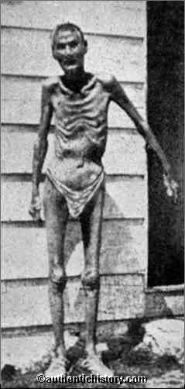
In order to separate the Cuban rebels from people in the countryside who might support them, the Spanish colonial government relocated Cubans living in rural areas to the cities. However, there was no enough food or medicine for the hundreds of thousands of Cubans who were placed in these “reconcentration camps.” As a result, 25%-30% of the Cuban population died of hunger or disease. The American media reported the conditions of these camps to the public. How do you think Americans reacted when they saw pictures like this one above in their newspapers?

Reading Passage #5- The U.S.S. Maine

In late 1897, the Cuban rebels began to gain the advantage over Spanish troops on the island. Knowing that the rebels had carried out a system of destruction throughout the Cuban countryside, American President William McKinley sent a group of battleships to Cuba to “observe” and to offer protection to American citizens and their investments in sugar plantations. One of these ships, the U.S.S. Maine, was dispatched directly to Havana Harbor.
Several uneventful weeks followed. The people in Havana grew accustomed to seeing the American battleship anchored in their harbor. But at 9:45PM on the night of February 15, 1898, a loud explosion rocked the city. As people lined the city walls and looked out to sea for the source of the explosion, they saw the Maine ablaze. The battleship sank quickly, killing 260 American naval officers and sailors.
Word traveled quickly via telegraph to the New York offices of Joseph Pulitzer’s The World newspaper. His paper was the first to report the news from Cuba at 3:10AM on February 16. William Randolph Hearst’s New York Journal was only moments behind with its own version of the incident. These newspapers reported the sinking of the Maine with sensational drawings of a boat exploding and bodies flying everywhere, some in pieces. The bold headlines read “Maine Explosion Caused by bomb or Torpedo?” or “Destruction of the War Ship Maine Was the Work of an Enemy!” No proof was ever uncovered that linked Spain to any wrongdoing, and the Spanish government denied that there had been any attempt of sabotage by their agents. Still, the newspapers reported on Spanish treachery, even making the statement that Spain was protesting too much to be believed. Newspapers were not the only media inciting the public. Thomas Alva Edison used his new invention, the motion picture camera, to film the burial of the Maine victims in Key West.
The American public demanded justice, and they felt that the only way to get it was to go to war with Spain. Under the slogan, “Remember the Maine,” the US Congress authorized President McKinley to send American troops to end Spanish control of Cuba. Five days later, on April 24, 1898, Spain declared war on the United States. The Cuban Revolution of 1895 had turned into the Spanish-American War. Almost a century later, U.S. Navy Admiral Hyman Rickover examined all available evidence and determined that an internal mishap, most likely a faulty boiler, caused the explosion. Do you think that the American press was guilty of causing war with Spain, or do you think it was inevitable in 1898?
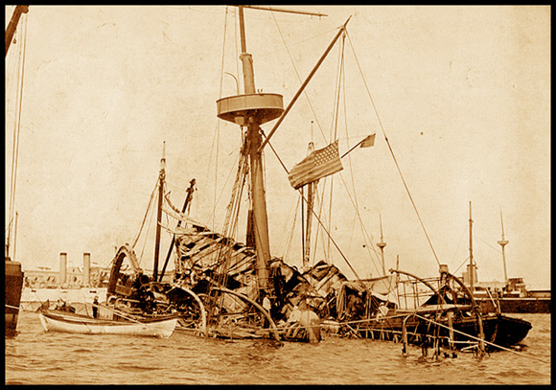
This is the Maine after it exploded and sunk on the night of February 15, 1898. This one event turned a small rebellion in Cuban into an all-out war between the United States and Spain. Four months later, the U.S. was victorious behind the battle cry “Remember the Maine!” Spain surrendered its colonies of Cuba, Puerto Rico, and the Philippines to the United States. Almost overnight, the U.S. had grown by 10 million people and had become a global power. How do you think other nations in Europe reacted to news that the U.S. was victorious over Spain?

Reading Passage #6-“Yellow Journalism”

Americans were eager for news from Cuba, and newspapers of the day were eager to give them that news. The Cuban Revolution of 1895 was covered extensively in American newspapers, and the resulting Spanish-American War in 1898 has been referred to as the first “media war.”
During the 1890s, newspaper publishers used journalism that exaggerated-and sometimes even completely invented dramatic events to outsell their competitors. The use of sensational headlines and stories, with little attention to actual facts, to attract the reader and stir his emotions was soon given a nickname: “yellow journalism.” It is unclear from where this nickname evolved. Historians think that it was either derived from the color of the paper used in the late 1800s, or from a popular comic-strip character of the time (“the yellow kid”). Whatever the source of this term, this type of journalism soon drove a nation toward war.
The two major newspapers of the time were William Randolph Hearst’s New York Journal and Joseph Pulitzer’s New York World. These men soon competed against each other and several other papers to be the first to report the “news” as it happened in Cuba, whether it was based on facts or not. Both men sent reporters, photographers, and Joseph Pulitzer published The World artists to Cuba to be the first to get the scoop. Upon receiving a telegraph from one of his staff stating that things in Cuba were slow and that there was no news to report, Hearst shot back his reply: “You furnish the pictures and I’ll furnish the war!”
Horrific but inaccurate stories continued to be printed for the American public to read. Stories and drawings of women and children being beaten and starved in Spanish-controlled reconcentration camps were common. “On the scene” reporters wrote about eye-witness accounts of mass executions by Spanish troops. Many articles were printed about brave Cuban rebels defending their families, homes, and honor against the hordes of cruel Spanish soldiers who burned down their villages, bayoneted their children, and ran off with their wives. As the American media fueled the public’s passion for a good yarn, it also caused most Americans to demand that their government take action to intervene in the struggle for Cuban independence on the side of the rebels.

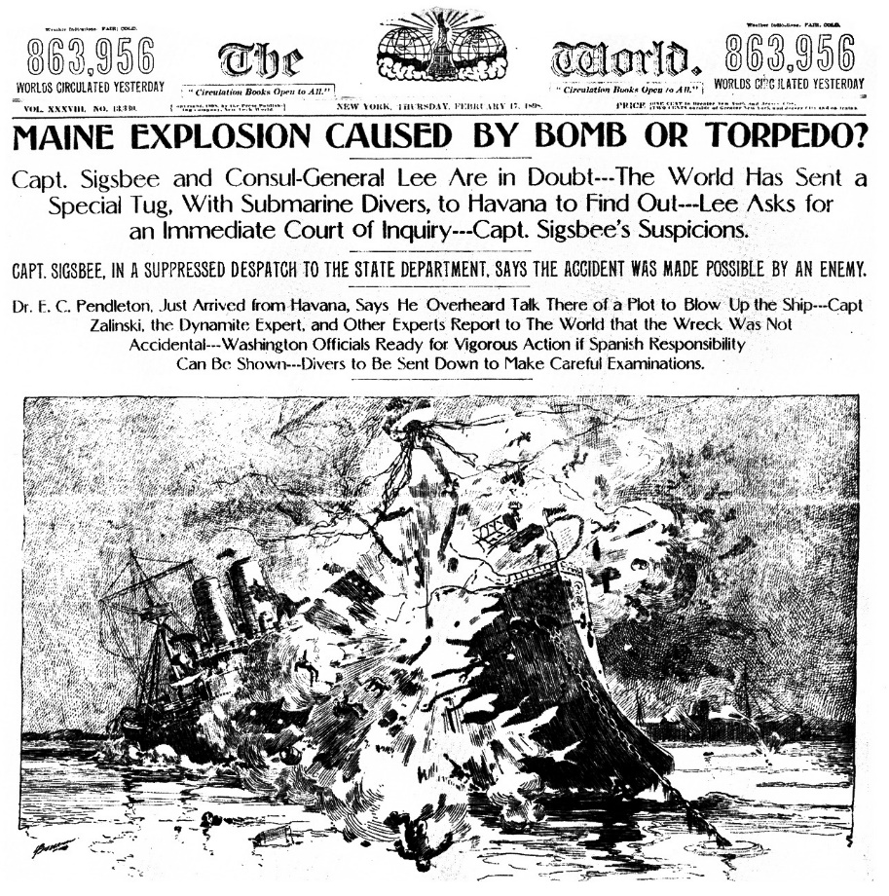

This is the front page of the New York Journal after the U.S.S. Maine exploded in Havana Harbor. Publisher William Randolph Hearst had instructed his staff covering the Cuban Revolution, “You furnish the pictures…I’ll furnish the war!” Look at the headlines. Do you think Hearst is publishing information that can be supported with evidence? How do you think that the coverage given to this event could influence Americans?

Reading Passage #7-Tampa’s Role in the Spanish-American War

With the outbreak of war in the spring of 1898, Florida was at an important crossroads in its history. No other state stood to gain more from this conflict than Florida because of its proximity to Cuba. No other state stood to lose more, either. Many Floridians living near the Atlantic and Gulf coasts were frightened at the possibility of an attack by Spanish warships. Even more frightening to many others was the real threat that Cuba posed to Florida’s young and thriving tourism industry. Many people felt that if the Americans were victorious, the US government would make Cuba a part of the United States. If that happened, tourists from the northern regions would pass right through Florida on the way to tropical Cuba. However, Henry Plant saw a real opportunity for his little city by the Gulf of Mexico.
In the years before the Spanish-American War, Tampa was a sleepy little town of 15,000 people, most of them Cuban immigrants. It contained twenty churches, three banks, seven public schools, and over 150 factories that exported almost ninety million cigars a year. By 1898, with the addition of Henry Plant’s Tampa Bay Hotel, over 35,000 tourists from around the nation had visited Tampa. But with war on the horizon, Plant realized that Tampa was in prime position to be the staging ground for troops departing for Cuba.
He convinced the Secretary of War to allow Tampa to be the official port of embarkation for troops going to Cuba. His railroad and steamship system helped move troops to Florida from other places, and then on to Cuba. The luxurious Tampa Bay Hotel became the headquarters for the US Army and provided lodging for its officers and news reporters. Here they enjoyed dances, fine food, and band concerts on a nightly basis. The common infantryman experienced a different Tampa. While Army officers were enjoying a working vacation, ground troops were sweltering in their heavy woolen uniforms. Their food spoiled in the brutal late spring sun, and they lived in tents set up in Tampa’s streets. One recruit from New York commented that on his first day in Tampa, he was “…bitten by mosquitoes, stung by a tarantula.” He also ran his bayonet into his hand, “…sat down on a giant ant’s nest, trod on an alligator,” and found a snake in his boot. Obviously, Tampa was not developed and modern in 1898.
By the time the war ended with Spain’s retreat and surrender four months later, this “splendid little war” had been very splendid for Tampa. Every soldier and piece of equipment that came to Tampa in 1898 arrived on a Henry Plant train, and many Army officials had stayed for many weeks in his Tampa Bay Hotel. Sixty thousand soldiers had spent large sums of money in local saloons and businesses while waiting for their orders to depart. In all, the Spanish-American War pumped over $4 million into Tampa’s economy, and made enough of an impression to cause many soldiers to return in later years.
But for some soldiers, the war was anything but splendid. Many soldiers were unaccustomed to the intense Florida heat and became very ill. Others caught mosquito-borne tropical illnesses or ate spoiled food. Some soldiers died from these or other maladies. This trend continued in Cuba. Over five thousand Americans died in the Spanish-American War, but only 385 from actual fighting. The others died from the same things that they suffered in Tampa.
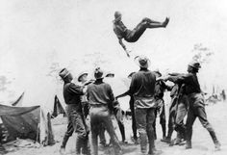
This is a painting of U.S. troops finding ways of entertaining themselves in the streets of Tampa before heading to Cuba. What ways can you see the troops experiencing Tampa?

Reading Passage #8-Lakeland and African-American Soldiers

The arrival of tens of thousands of Army troops to Tampa in the weeks after April 1898 caused a great deal of overcrowding. Tampa was simply unable to cope with the large number of soldiers arriving by train daily. When there was no more room on Tampa’s streets, hundreds of soldiers were forced to stay in the swamps and forests outside Tampa. At that point, the US War Department made the decision to move five units totaling nine thousand troops to Lakeland, approximately thirty miles east of Tampa. Lakeland was selected as a site to quarter troops because of its good rail connections to Tampa, its abundant water supply, and its proximity to Port Tampa, where soldiers would eventually board a steamship for Cuba.
Lakeland’s population of just over a thousand quickly swelled to ten times its normal size with the influx of soldiers. Though the small town did cope remarkably well, there were some difficulties. Most soldiers stationed in Lakeland were from the northeast part of the United States, and they were forced to adjust to the oppressive central Florida heat and humidity that were absent in their hometowns in the spring. Heat exhaustion was the most common ailment among the soldiers. Troops also had to reckon with mosquitoes and shortages of food, milk, and ice. All of these problems could not compare with the obstacles faced by a late-arriving group of soldiers, though.
When war broke out, the US War Department made a concerted effort to recruit black men as soldiers. Many doctors wrongly believed that, unlike whites, African–Americans were immune to tropical diseases spread by mosquitoes. Medical science of the day also stated that blacks were more capable of physical exertion in high temperature. So, in May 1898, four regiments made up entirely of African-American men (except for the white officers) arrived in Tampa. They had encountered every form of ill treatment on their journey from their homes in the North, and they immediately encountered racism and prejudice from white Tampans, as well as from their own white counterparts. Even the laws of the day were discriminatory in the South, and Tampa was no exception. These “Jim Crow” laws forbade blacks from entering white-owned businesses and forced them to give seats in the front of trains and streetcars to white people. These soldiers were shocked by the blatant discrimination that they encountered.
Partly to relieve some of the overcrowding, and partly to move some black troops out of Tampa to prevent any negative situations, one regiment was moved. The 10th Cavalry (of which one of its junior white officers, John J. “Black Jack” Pershing, would later gain fame as the leader of all American forces in Europe in World War I) was ordered to Lakeland, where it would attempt to peacefully coexist with the 2nd Massachusetts, the 71st New York Volunteers, and the town’s citizens. Hours after arriving, though, several black soldiers found themselves in a violent confrontation that ended with one white Lakelander dead and two black soldiers arrested. As one of the soldiers recalled later, “…some of our boys…went into a drug store and asked for some soda water. The druggist refused to sell to them, stating he didn’t want their money, to go where they sold black drinks. That did not suit the boys and a few words were passed…. (a white man)came into the drug store and said: ‘You n------ better get out of here…or I will kick you black s--- of b------ out,’ and he went into his barbershop next to the drug store and got his pistols….Some of the boys saw him get the guns…they never gave him a chance to use them. There were five shots fired and each shot took effect.” Other sources said that these same soldiers then started firing their pistols in the street, shooting a bystander. The next day, a black soldier took a shot at one of his white officers after word got around that some of the townspeople of Lakeland and a few white soldiers were plotting revenge.
A few weeks later, these African-American soldiers proved just as brave as their white counterparts on the battlefield. In the Battle of Guasimas, the all-black 9th and 10th Cavalries inflicted heavy losses on the Spanish and opened the way for the more-famous Rough Riders, led by Theodore Roosevelt, to charge San Juan Hill.

Warm Up: Does the United States have the right to intervene when two other nations are at war? What is our government’s responsibility when one nation is much stronger than the other, or when the fighting is in a place very close to our own country?

Background:
“By the end of the 1800s, Spain had lost almost all of its former New World colonies. Once a proud empire that had controlled almost all of Central and South America, North America (including Florida) and the Caribbean since the 1500s, Spain was left with Cuba and Puerto Rico as the century drew to a close. Many Cubans did not wish to be a part of Spain’s empire any more. Many years prior to the end of the 19th century, Cuban rebels had been active in trying to force Spanish forces to leave the island. In the ensuing violence, many Cubans fled their homeland and immigrated to the United States. However, they always remained loyal to Cuba. 2 While Cubans were battling their Spanish rulers in the last half of the 1800s, the United States had grown from a country that occupied a small portion of North America to a land that stretched from the Atlantic to the Pacific. New technologies like the telegraph and the railroad linked both sides of this massive nation. In the last years of the 19th century, with the United States having reached its continental limits, focus began to turn to lands outside of the continent. American manufacturers and businesses began to export goods to foreign markets and developed foreign trade that became vitally important to our nation’s growing economy. This new “economic expansionism” caused many Americans to support the idea of gaining territories outside of North America. These new territories would provide new areas of settlement and more economic opportunities for Americans, provide bases from which to defend American interests all over the world, and enable the United States to become a global power much like Great Britain, France, and Germany. For years prior to the 1890s, American businessmen had invested millions of dollars into Cuban sugar plantations. Many Americans lived in Cuba. The United States traded a great deal with the Spanish in Cuba. However, with global expansion on their minds, many Americans began to look at Cuba in a new light.”

Summary: The Spanish-American War resulted in the United States taking a more active role in the world and began what was later called the “American Century.” But was this war a just war, or a flagrant attempt to take land and wealth at a weaker nation’s expense? Justify your answer with 3 facts to back up your point

Document and Picture Number | How does the picture help explain the topic’s role in the Spanish American War? | Give 2 details from the passage that explain the role the topic played in the Spanish American War
#1

#2

#3

#4

Document and Picture Number | How does the picture help explain the topic’s role in the Spanish American War? | Give 2 details from the passage that explain the role the topic played in the Spanish American War
#5

#6

#7

#8

