1. The information below identifies examples of the Progressivism work of the muckrackers.
- Upton Sinclair exposed the unhealthy practices of Chicago’s meat-packing plants.
- Ida Tarbell revealed the dishonest busisness tactics of Rockefeller’s Standard Oil Company
- Jacob Riis wrote How the Other Half Lives, showing the conditions of residents of New York City tenements

What was the impact of these progressive muckraking activities during the early 1900s?
- Society changed in response to their promotion of social Darwinism | - Voters agreed to let the owners of Big business create more profitable monopolies
- Reports of these works in publications abroad led to a sudden decrease in immigration | - Public reaction to their works led to new laws addressing the abuses of industrialization

2. Progressivism could best be characterized as a movement that?
- A. encouraged involvement in international affairs.
- B. tried to introduce a parliamentary system of government.
- C. emphasized only the needs of farmers.
D. demanded reform at all levels of government

3. President Woodrow Wilson's Fourteen Points were proposals that he believed would bring about
- A. a just and lasting peace.
- B. the containment of fascism.
- C. a reduction in United States involvement in world affairs.
- D. a reestablishment of the prewar political situation in Europe.

4. Roosevelt believed that Taft’s focus on breaking up the trusts would ?
A. Promote competition and lower prices from consumers
B. Please progressives and help the Republicans stay in power
C. Destroy the system of cooperation & regulation Roosevelt arranged
D. Ruin the efficiency of business and cause prices to drop
5. During the late nineteenth and early twentieth centuries, the passage of antitrust legislation and the establishment of the Federal Trade Commission reflected the United States desire to
- A. eliminate unfair practices in business.
- B. help big business to become more efficient.
- C. encourage increased production of goods.
D. stimulate the growth of modern transportation
6. Look at the following cartoon created in the early twentieth century and answer the question below.
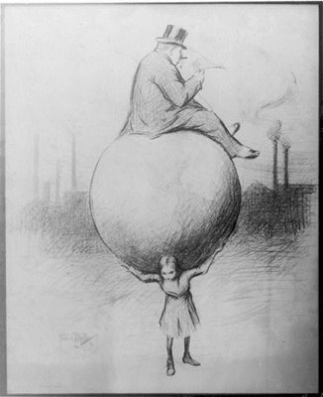

How did social reformers address the issue shown in this cartoon?
- by creating organizations to help workers and the poor | - by disapproving of income tax increases for the wealthy
- by supporting extended protections for religious minorities | - by petitioning for immigration restrictions on women and children

7. Read the following excerpt from an article written by Jane Addams in 1897 and answer the question below.
Italian parents count upon the fact that their children learn the English language and American customs before they themselves do, and act not only as interpreters of the language about them, but as buffers between them and Chicago. . . .
­Jane Addams, "Foreign­Born Children in the Primary Grades," National Educational Association, Journal of Proceedings and Addresses 36, 1897 University of Illinois at Chicago/Public Domain
Which idea is best described in this excerpt?
- improving college admission guidelines for Italians | - Providing financial aid to educate immigrant children
- offering government sponsored language classes for Italians | - educating immigrant children to influence the daily lives of adults

