Politics of World War II

Warmup: Compare the 2 maps on page 400. Why would Germany and the Soviet Union want stronger leaders based on the map?

Part I: Political philosophies- use the text pages given to complete the chart below

 | Communism pages 413, 529 | Fascism page 530 | Nazism page 531
Definition
Example 1
Example 2
Example 3

Part 2: Use the pages above to answer the questions below

- What are the characteristics of a totalitarian state?

- What factors led to the rise of fascism in Italy?

- What were the goals that Hitler presented in Mein Kampf?

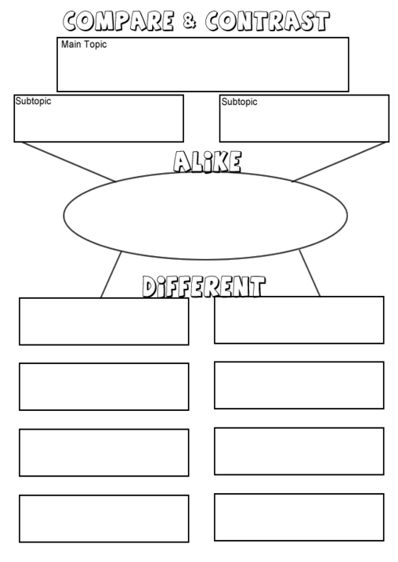
Fascism
Communism
Politics of World War II

