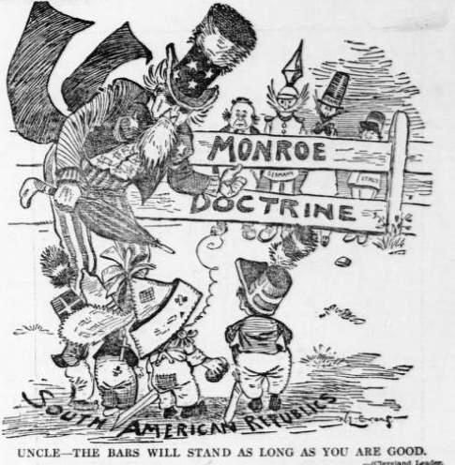
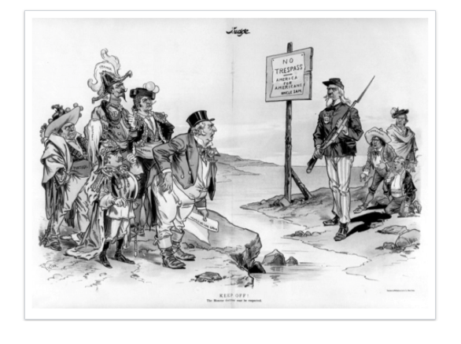
Political Cartoon A Political Cartoon B

1.) Using the political cartoons, answer (a), (b), and (c).

- ) Briefly explain the point of view on the Monroe Doctrine for political cartoon A.
- ) Briefly explain the point of view on the Monroe Doctrine for political cartoon B.
- ) Choose political cartoon A or political cartoon B and explain how it shows a continuity or change to American Foreign policy.

