Kennedy and the Cold War pages 673-678

Warm up: Read “Defining a military strategy” on page 673.

What was flexible response?

What was the goal of flexible response?

Part I: Crisis over Cuba, The Cuban Dilemma, and The Bay of Pigs pages 673-674

- What caused the problems between the U.S. and Cuba under Eisenhower?

- How was Florida affected by the Cuban Coup of Fidel Castro?

- Why do you think Kennedy went ahead with the invasion of Cuba even though he had doubts?

- What were the effects of the failed invasion of Cuba?

Summary I: How well did Kennedy use flexible response to deal with the Cuban Dilemma? Explain.

Part II: The Cuban Missile Crisis and Kennedy and Khrushchev take the Heat pages 674-677

- What are 2 causes of the Cuban Missile Crisis?

- How did the Cuban Missile Crisis affect Florida?

- What did each side give up in order to solve the Cuban Missile Crisis?
  - U.S.A.-

  - Soviet Union-

- What effects did the crisis have on the Soviet Union and the U.S.?
  - U.S.A.-

  - Soviet Union-

Summary II: How well did Kennedy use flexible response to deal with the Cuban Missile Crisis?

Part III: The Berlin Wall pages 677-678

- Complete the cause and effect map below
Cause | Event | Effect
 | The Berlin Wall was built to separate East and West Germany

Summary III: How well did Kennedy use flexible response to deal with the Berlin Wall crisis?

Part IV: POSES
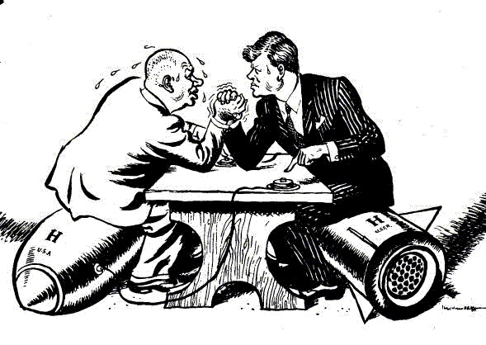
People:

Objects:

Setting:

Engagement:

Summary:

