Herbert Hoover and the Depression pages 478-483

Warmup: Herbert Hoover campaigned for President with the pledge, “A chicken in every pot and a car in every garage.” What do you think he meant by this?

Part I: Analyze the decisions of Herbert Hoover during the depression and decide if it was positive or negative and explain why you think that

Action | Positive or negative | Why
Belief in rugged individualism
Boulder (Hoover) Dam
Federal Farm Board
National Credit Corporation
Glass-Steagall Act
Reconstruction Finance Corporation
Gassing the Bonus Army

Part 2: Explain how each of these groups were affected by Hoover’s policies

California
Farmers
Republicans
Veterans

Part 3: POSES Summary

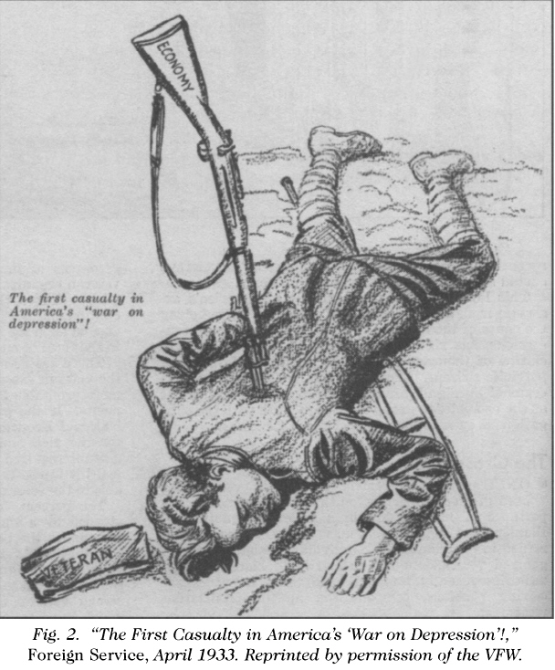
P:

O:

S:

E:

S:

