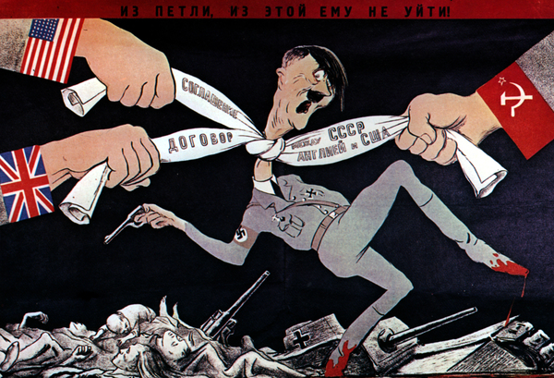
Bell Work:
1.) In what ways did the Allies work together in World War II?
2.) What disagreements or conflicts did the Allies have with one another?

Stations: Located around the room are seven stations. You will go to each station and complete the guided questions for each station.

Yalta Conference and Dumbarton Oaks and

3.) Discussions during the Yalta Conference led to what two conditions for Germany after World War II?

4.) What was negotiated at the Dumbarton Oaks Conference?

United Nations and Declaration of Human Rights

5.) Explain the negatives of the United Nations.

6.) In you opinion was The Declaration of Human Rights something that every country was going to enforce?

Potsdam Conference

7.) Why were many Americans doubtful about Truman taking over the presidency?

8.) What promise did Stalin break during the Conference?

Iron Curtain and Satellite Nations

9.) What reason did Stalin give for creating the Iron Curtain?

10.) Explain what satellite nations were and give three examples.

Truman Doctrine, Marshall Plan, and Containment

11.) In your own words, explain the reason for The Truman Doctrine.

12.) What were the benefits of the Marshall Plan?

NATO

13.)What are the benefits of joining an alliance like NATO?

14.)What are the costs of joining an alliance like NATO?

Warsaw Pact

15.) Why would the Soviet Union need to create the Warsaw Pact?

Summary:

What was the rationale for forming the United Nations? Give two examples from the stations in your writing response.

