Map of Europe 1941
Use the directions and the map on page 538 of your text to fill in the blank map below.

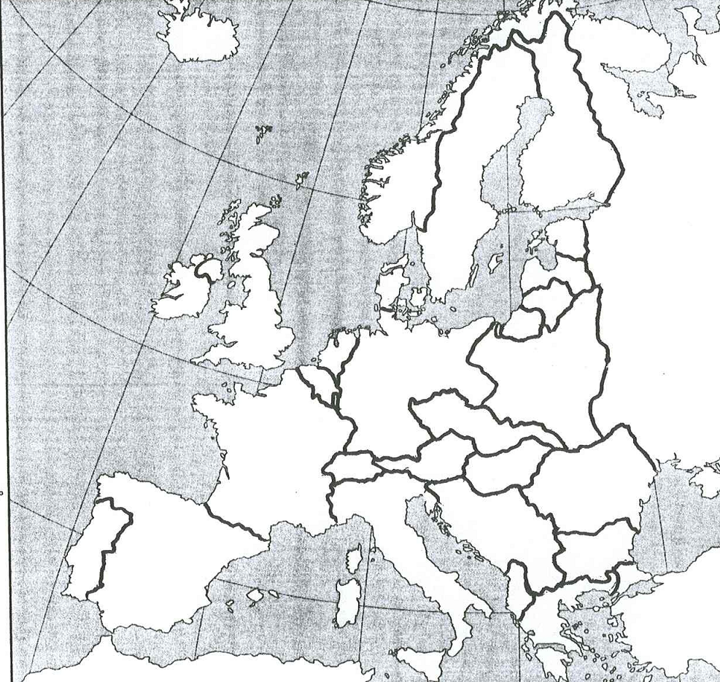

Europe Map of 1941 directions
- Label the following countries: Germany, France, Belgium, The Netherlands, Denmark, Great Britain, Ireland, Soviet Union, Italy, Switzerland, Spain, Portugal Czechoslovakia, Austria, Hungary, Poland, Norway, Finland, Sweden, Estonia, Latvia, Lithuania, East Prussia, Yugoslavia, Romania, Bulgaria, Albania, Greece, Turkey

- Choose a color and shade in Ireland, Sweden, Switzerland, Spain, and Portugal. These are the neutral Countries. What do most of the neutral countries have in common?

- Choose another color and shade in Great Britain and the Soviet Union. These are the only countries that the allies still controlled by 1941. Why might the United States find ways to help Great Britain and Russia?

- Choose another color and shade in the areas that are left. These are the Axis territories. What advantages and disadvantages do the Axis powers have based on the map.
Advantages | Disadvantages

- Under the terms of the Treaty of Versailles after World War I, Germany had to pay large amounts of money to the allies for war damages, Germany was blamed for the war and lost territories that were near them, and Germany was not allowed to maintain an army. Based on the map, how has Germany violated this Treaty?

- In 1939, Germany signed a secret agreement with the Soviet Union to not attack each other and to split Poland in half. What advantage would Germany get out of an agreement like this?

- France, Belgium, and the Netherlands were actually Allies, yet on the map are shaded with the Axis powers. Why is this so? What problem does this create for the Allies?

Causes of World War II
Part I Dictators – skim pages 328-533. Fill in the chart of the dictators and their countries
Name of Dictator | Name of country | Axis or Allies

- How would dictators upset the balance and cause a war?

Part II: League of Nations- Read “Aggression in Europe and Africa” on pages 532-533
- How did the League of Nations help cause World War II?

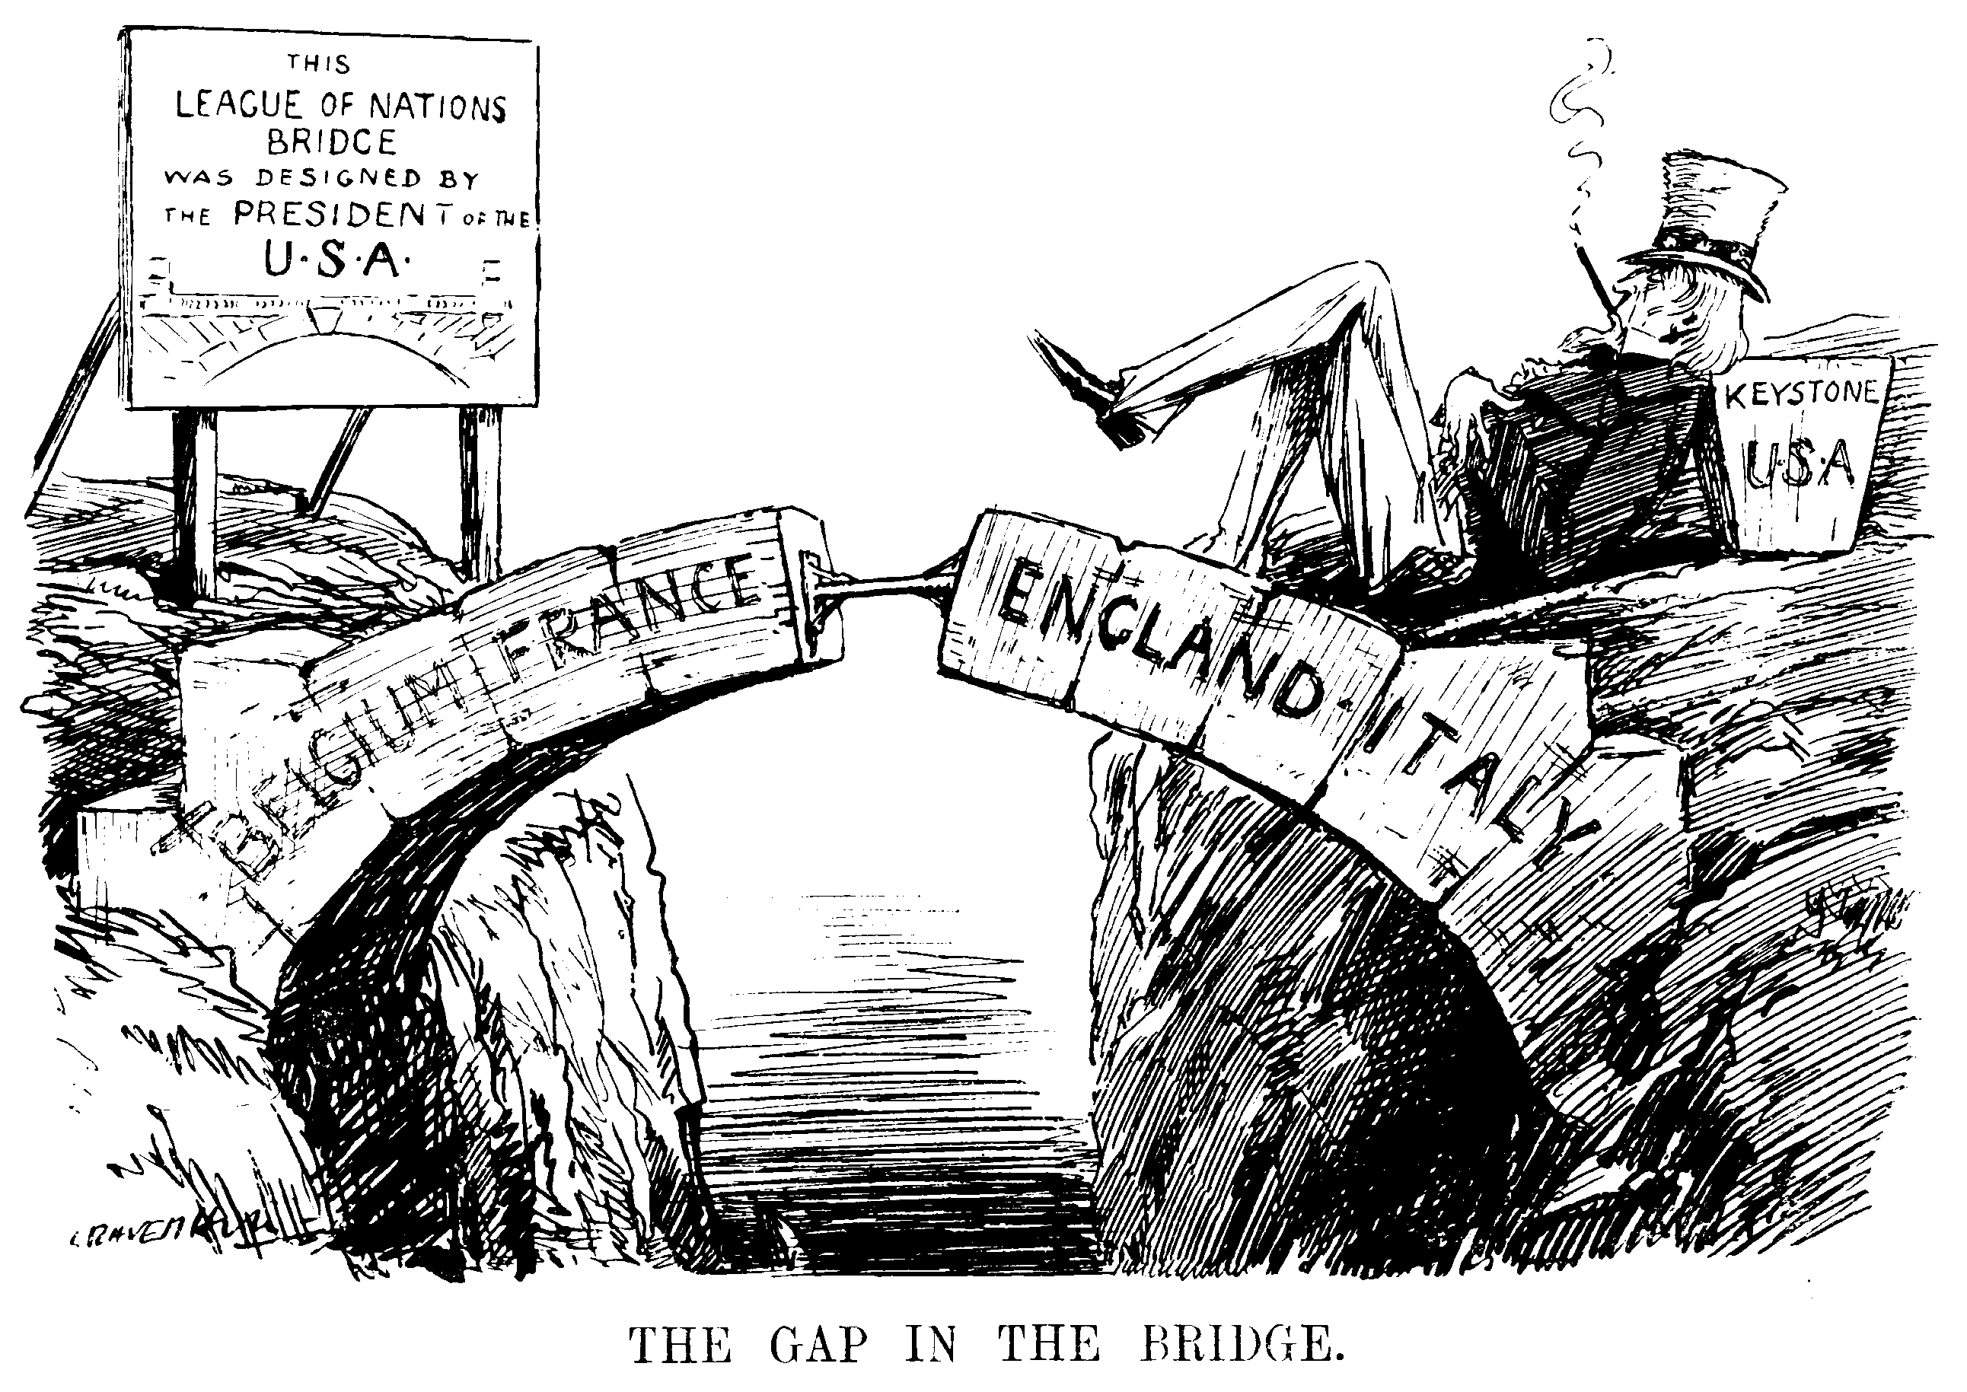
- How does the cartoon help explain one of the problems with the League of Nations?

Part III: Appeasement-Read “Austria and Czechoslovakia Fall” on pages 536-538
- What caused Germany to want to take over lands close to them?

- How did Hitler attempt to convince people his occupation of Czechoslovakia was warranted?

- Why do you think Winston Churchill felt the Munich Agreement and appeasement was not going to work?

