Bell work: The Vietnam War became the most unpopular war in recent U.S. history. At first, most Americans supported the decision to help South Vietnam. But as the war dragged on and the troop commitment grew, many Americans grew disenchanted with the conduct of war. In your opinion, should the U.S. have joined the Vietnam War?

Doves & Hawks
“Doves” wanted the United States to withdraw from the Vietnam War. They saw the contest as a civil war between the Vietnamese in which the United States simply had no business. Many Doves, including Dr. Martin Luther King Jr., thought the war was immoral. The United States was bombing so many civilians and burning down so many villages that it was destroying Vietnam in order to save it. “Hawks” believed it was important to stop the spread of Communism. They saw the war as the defense of South Vietnam, a sovereign country, against an invasion from the North. Most Hawks thought that an all-out military effort in Vietnam could bring victory. They wanted to invade the North. A few favored the use of tactical nuclear weapons, which they thought would force the North Vietnamese to surrender.
1.) What was the Doves justification for not joining Vietnam?

2.) What was the Hawks justification for joining Vietnam?

The New Left and Teach Ins
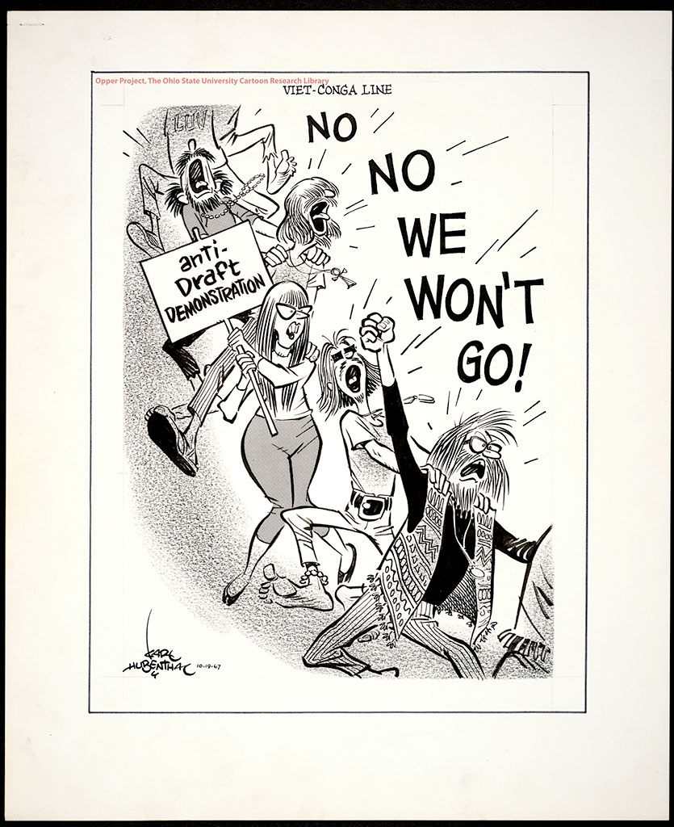
The growing youth movement of the 1960s became known as the New Left. The movement was “new” in relations to the “old left” of the 1930s, which had generally tried to move the nation towards socialism, and, in some cases, communism. While the New Left movement did not preach socialism, its followers demanded sweeping changes in American society. One of these changes occurred at college campuses across America. In the spring of 1965, groups at a number of colleges began to host “teach-ins” to protest the war. At the University of Michigan, where only a year before president Johnson had announced his Great Society Program, teachers and students now assailed his war policy. “This is no longer a casual form of campus spring fever,” journalism James Reston noted about the growing demonstrations. As the war continued, the protests grew and divided the country.
3.) What was the change from the “old left” to the “new left”?

4.) Why were teach ins considered part of the “New Left”?

Draft / Anti-war Protesters
In the late 1960’s, concerns focused on escalating American involvement in Vietnam. Young men over the age of 18 were subject to compulsory military conscription, better known as the “draft”. As in earlier conflicts, conscientious objectors who could prove they opposed all wars as a matter of religious belief were excused from service, but not those who were against the war on political grounds. Draft-aged men opposed to the war protested by burning their draft cards. Some draft resisters fled to Canada or Sweden. At the beginning of the war, college students were deferred from the draft until they completed their studies. Anti-war protestors organized marches and demonstrations in the nation’s capital, on college campuses, and in major cities. In the spring of 1970, Nixon announced the invasion of Cambodia. At Kent State University in Ohio, local National Guardsmen were called in to control an anti-war demonstration. Several of the inexperienced guards fired, killing four students and wounding nine others. An estimated four million student went on strike throughout the nation.
5.) What groups of people were exempt from fighting in the Vietnam War?

New York Times v. Nixon and the “Credibility Gap”
Newspaper reporters and television journalists played an increasingly important role in presenting the Vietnam War to the American public. This was the first televised war. Modern television reporting brought the bloody horrors of war into the average American living room. Many Americans were influenced when the CBS anchor Walter Cronkite turned against the war at the end of the 1967. American political leaders realized that they not only had to fight the war but also had to manage its public relations. Their concern to impress the public favorably often led to a twisting of the facts and to a growing “credibility gap”. For example, President Johnson claimed that bombing had injured few North Vietnamese civilians, but a New York Times reporter in North Vietnam found just the opposite. Johnson told Americans that the United States was winning the war, but the public received a different impression from nightly television broadcasts on television during the Tet Offensive. People began to lose faith in the trustworthiness of their own government. Nixon was even more secretive that Johnson, further widening the “credibility gap”. Nixon attempted to prevent the New York Times from publishing the Pentagon Papers, a secret government study of American involvement in Vietnam. The Supreme Court ruled against him in NY Times v. United States (1971) on the basis of freedom of the press.
6.) Why would a credibility gap create tension between the president of the United States and the citizens?

Silent majority and Linkage
Seeking to win support for his war policies, Richard Nixon appealed to what he called the silent majority. This was moderate mainstream Americans who quietly supported the U.S. efforts in Vietnam. While many average Americans did not support the president, the events of the war continued to divide the country. The idea of "Vietnamization" was put in place, were the responsibility for fighting would be turned over to the Vietnamese, in order to reduce American casualties. Gradually American forces would be withdrawn. This would buy time on the home front. Nixon also applied the principle of "linkage" in dealing with the Soviet Union. This was a trade agreement to be proposed to the Soviets that would require a this for that trade deal. The U.S. persuaded the Soviet Union and Communist China to co-operate in restraining revolutions in the Third World in return for trade in nuclear and economic fields. However, despite this lack of Soviet intervention, a large number of revolutions still occurred in these third world countries, thereby undermining this policy.

Summary:
Why did so many Americans disagree with the Vietnam War? On a piece of lined paper, write a summary using at least two pieces of evidence from your reading.

