Imperialism in America

Part I warm up: What are the positives and negatives of becoming a colony?
Positives | Negatives

Part II American Expansion pages 342-344
- What is Imperialism?

- Why do you think the U.S. Would want to get involved with imperialism?

- Explain how each of these concepts helped create the desire of imperialism in America
  - Military

  - Economic

  - Cultural

Part III The United States Acquires Alaska and takes Hawaii pages 344-345
- Why do you think people were against buying Alaska?

- How did time prove the purchase of Alaska to not be folly?

- What is one reason why the American planters had the right to revolt in Hawaii?

- What is one reason why the American planters did not have the right to revolt in Hawaii?

- Explain three reason why Hawaii was important to the U.S.

- In your opinion, should Hawaii have been annexed? Why or why not?

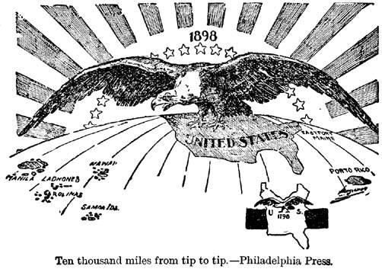
Part IV summary complete the POSES

P:

O:

S:

E:

S:

