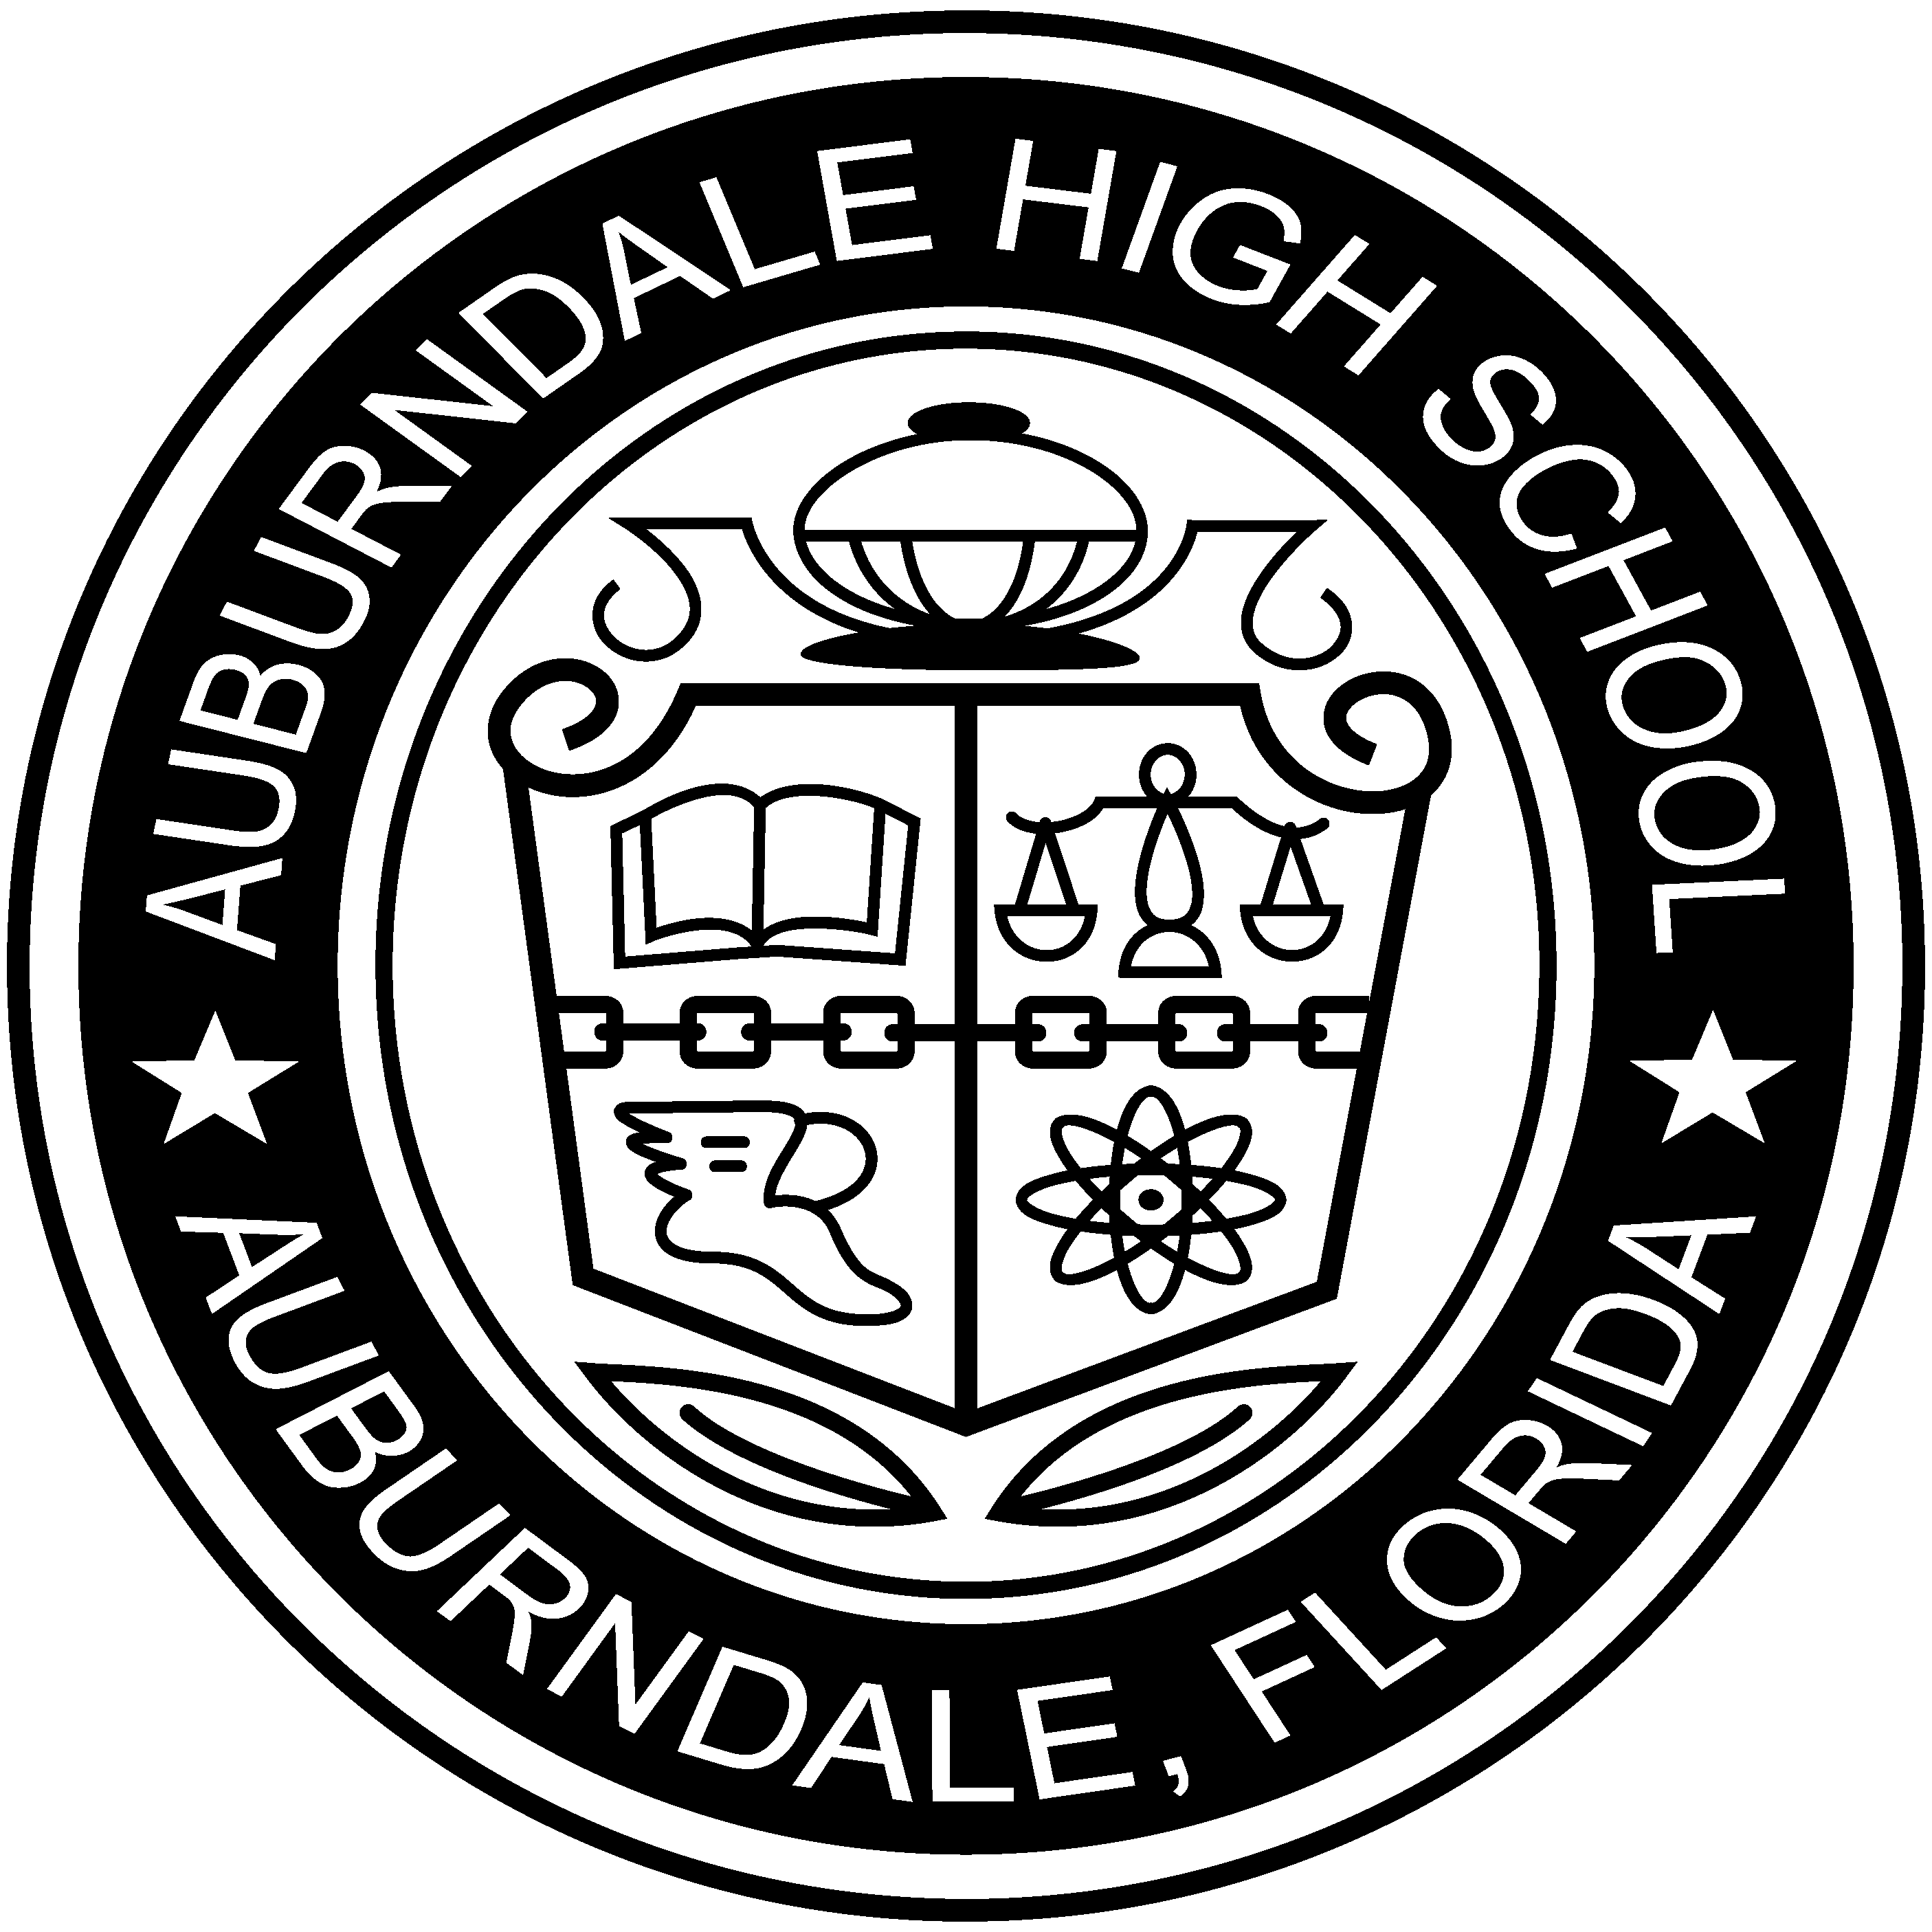3 | Welcome to A.P. U.S. History!  Mrs. Katelyn Nykiel

CONTACT INFORMATION:
- Mrs. Katelyn Nykiel
- Phone: 585-590-0477
- Available for helping students: After School 2:00-3:00 with prior arrangement
- Class Website: www.mrsnykiel.weebly.com
- e-mail: katelyn.nykiel@polk-fl.net
PREREQUISITES TO THE COURSE:
Students should have successfully completed AP World History, Honors American and/or World History or have a positive recommendation from the previous Social Studies teacher. Students should possess the ability to read and understand written communication above the high school level. Students must have good oral communication skills and a desire to learn and to be in an accelerated AP class for U.S. History. Keys to doing well in this AP U.S. History class and on the AP Exam include desire for high level classes, maturity, and work ethic.
GENERAL LEARNING GOALS OR OBJECTIVES:
- an understanding and appreciation of history and historical enquiry.
- an ability to think critically, analytically and systematically.
- an ability to organize different types of source materials, relate them to each other by means of critical analysis, and use them in a way that produces greater insight into the complex subject matter of the course.
- a sense of history as combining a variety of disciplines and approaches.
- an appreciation for the contribution that an historical perspective can bring to other disciplines.
- a greater ability to express oneself clearly and concisely on paper and orally.
- a greater understanding of the human condition and experience by examining the dilemmas and challenges faced by men and women of the past.
- Skills and understanding needed for the AP Exam administered at the end of the school year.
COURSE MATERIALS:
- Text: By the People (School provides online version and Hard copy if needed)
- Binder with organizational tabs (size is up to you)
- Notebook Paper and a writing utensil
- Highlighters- your choice of colors
- Strongly recommend purchasing the Kaplan AP U.S. History study book
- Strongly recommend a storage solution such as a flashdrive, dropbox, evernote, etc…
COURSE DESCRIPTION:
Welcome to AP U.S. This course is a rigorous examination of AP U.S. History in preparation for the AP exam in May. The AP exam is a difficult one and the best students in the country take this course. It will be the most challenging and rewarding History course you have taken thus far in your academic career. The course will be conducted as a college seminar with a great deal of class discussion and greater responsibility placed on you than perhaps any course you have taken thus far in high school. In addition to the academic content, the class will work on developing skills that are necessary to do well on the exam and will benefit you in your future academic life. These skills include writing analytically, interpreting historical documents, evaluating history from multiple perspectives, speaking skills, and so on.

COURSE CONTENT AND OUTLINE:
Advanced Placement U.S. History is a college level survey course of U.S. history from the pre-Columbian period to the present.

Themes:
▶ American and National Identity
This theme focuses on how and why definitions of American and national identity and values have developed, as well as on related topics such as citizenship, Constitutionalism, foreign policy, assimilation, and American exceptionalism.

▶ Politics and Power
This theme focuses on how different social and political groups have influenced society and government in the United States, as well as how political beliefs and institutions have changed over time.

▶ Work, Exchange, and Technology
This theme focuses on the factors behind the development of systems of economic exchange, particularly the role of technology, economic markets, and government.

▶ Culture and Society
This theme focuses on the roles that ideas, beliefs, social mores, and creative expression have played in shaping the United States, as well as how various identities, cultures, and values have been preserved or changed in different contexts of U.S. history.

▶ Migration and Settlement
This theme focuses on why and how the various people who moved to and within the United States both adapted to and transformed their new social and physical environments.

▶ Geography and the Environment
This theme focuses on the role of geography and both the natural and human-made environments on social and political developments in what would become the
United States.

▶ America in the World
This theme focuses on the interactions between nations that affected North American history in the colonial period, and on the influence of the United States on world affairs.
All questions on the AP U.S. History Exam will measure student understanding of the specified thematic learning objectives

Classroom Procedures and Conduct:

Follow these procedures:
- Respect Yourself: This is your education. Pay attention and put forth effort to advance yourself through this class and on the path to college and/or career.
- Respect others: Those around you have a right to an education and a classroom conducive to learning. Please respect that.
- Respect the Teacher: My job is to prepare you to be able to pass this class, pass the test, and be prepared for college and career. I am here to help you. Please respect that process.
- Respect the School: The property of the school is important to the learning environment. No one wants to think of their school as dirty or rundown.
- School policy on tardies, dress code, cell phones, and disruption will follow the code of conduct
GRADING/EVALUATION:
All assessments will be graded as 60% of the overall grade. All other work will make up 40% of the overall grade.
AMERICANS WITH DISABILITIES ACT:
Students with special needs are invited to contact me during the first week of school.
SYLLABUS CHANGE POLICY:
This syllabus is a guide for the course and is subject to change in the event of extenuating circumstances.

